Problem 1
Part-a
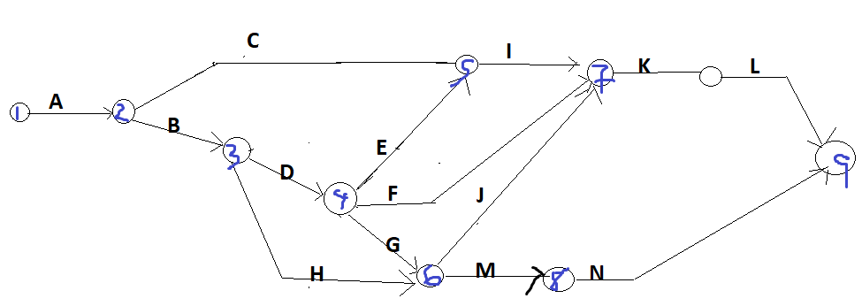
Part-b
Index | Optimistic | Pessimistic | Most Likely | Mean Time (Weeks) | Variance
A | 1 | 3 | 2 | 2 | 0.111111
B | 2 | 8 | 3.5 | 4 | 1
C | 6 | 18 | 9 | 10 | 4
D | 4 | 10 | 5.5 | 6 | 1
E | 1 | 5 | 4.5 | 4 | 0.444444
F | 4 | 10 | 4 | 5 | 1
G | 5 | 11 | 6.5 | 7 | 1
H | 5 | 17 | 8 | 9 | 4
I | 3 | 9 | 7.5 | 7 | 1
J | 3 | 9 | 9 | 8 | 1
K | 4 | 4 | 4 | 4 | 0
L | 1 | 7 | 5.5 | 5 | 1
M | 1 | 3 | 2 | 2 | 0.111111
N | 5 | 9 | 5.5 | 6 | 0.444444

The mean is (Optimistic + Pessimistic + 4*Most Likely)/6 and the variance is
((Pessimistic – Optimistic)/6)^2

Part-c

Part-d
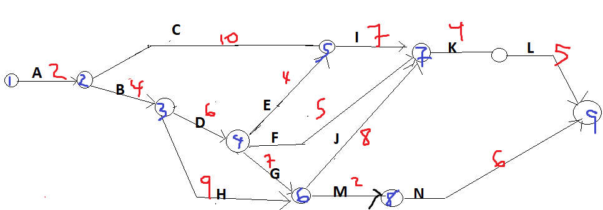
The critical path is
ABDGJKL =2+4+6+7+8+4+5= 36
The next critical path is
ABDEIKL = 2+4+6+4+7+4+5 = 32
Part-e
P(X < 47) = P(Z < (47 – 36)/sqrt(5.1111)) = P(Z < 4.87) = 1 (almost 1)

Part-e
P(X < 47) = P(Z < (47 – 36)/sqrt(5.1111)) = P(Z < 4.87) = 1 (almost 1)
Part-f
P(X < 43) = P(Z < (43 – 36)/sqrt(5.1111)) = P(Z < 3.10) = 0.9990

Problem 2
Part-a
ABCDGHM = 2+4+10+6+7+9+2=40
ABCEHM = 2+4+10+4+9+2=31
ABCEFJKN = 2+4+10+4+5+8+4+6= 43
ABCEFJLN = 2+4+10+4+5+8+5+6 = 44
ABCIJKN = 2+4+10+7+8+4+6= 41
ABCIJLN = 2+4+10+7+8+5+6 = 42
Length of Path
ABCDGHM | ABCEHM | ABCEFJKN | ABCEFJLN | ABCIJKN | ABCIJLN
40 | 31 | 43 | 44 | 41 | 42

Part-b
The critical path is ABCEFJLN = 2+4+10+4+5+8+5+6 = 44
We apply the marginal cost analysis
The smallest crash cost per week saved is activity J which is on the critical path
 |  | Length of Path
Crash Activity | Cost Involved in Crashing | ABCDGHM | ABCEHM | ABCEFJKN | ABCEFJLN | ABCIJKN | ABCIJLN
 |  | 40 | 31 | 43 | 44 | 41 | 42
J | $ 30,000 | 40 | 31 | 42 | 43 | 40 | 41

ABCEFJLN = 43 is still the critical path, so the activity to crash in the next step is J
 |  | Length of Path
Crash Activity | Cost Involved in Crashing | ABCDGHM | ABCEHM | ABCEFJKN | ABCEFJLN | ABCIJKN | ABCIJLN
 |  | 40 | 31 | 43 | 44 | 41 | 42
J | 30,000 | 40 | 31 | 42 | 43 | 40 | 41
J | 30,000 | 40 | 31 | 41 | 42 | 39 | 40

ABCEFJLN = 42 is still the critical path and the next activity to crash is Activity F (cost = $40,000) since we J cannot be shortened further
 |  | Length of Path
Crash Activity | Cost Involved in Crashing | ABCDGHM | ABCEHM | ABCEFJKN | ABCEFJLN | ABCIJKN | ABCIJLN
 |  | 40 | 31 | 43 | 44 | 41 | 42
J | 30,000.00 | 40 | 31 | 42 | 43 | 40 | 41
J | 30,000.00 | 40 | 31 | 41 | 42 | 39 | 40
F | 40,000.00 | 40 | 31 | 40 | 41 | 39 | 40

ABCEFJLN = 41 is still the critical path and the next activity to crash is Activity F (cost = $40,000)
 |  | Length of Path
Crash Activity | Cost Involved in Crashing | ABCDGHM | ABCEHM | ABCEFJKN | ABCEFJLN | ABCIJKN | ABCIJLN
 |  | 40 | 31 | 43 | 44 | 41 | 42
J | 30,000.00 | 40 | 31 | 42 | 43 | 40 | 41
J | 30,000.00 | 40 | 31 | 41 | 42 | 39 | 40
F | 40,000.00 | 40 | 31 | 40 | 41 | 39 | 40
F | 40,000.00 | 40 | 31 | 39 | 40 | 39 | 40

We have a cost of 30,000 + 30,000 + 40,000+ 40,000 = 140,000 associated with reducing the duration by 4 weeks

Problem 3
Part-a
Part-b
SV $ = BCWP – BCWS = 50 – 25 = 25
SV % = SV$ / BCWS = 25/25 = 1 or 100%
Since SV is positive, the project is ahead of schedule on 5/4/2020
Part-c
CV $ = BCWP – ACWP = 50 – 55 = -5 which is negative, therefore the cost is above budget or overrun

Part-d
SPI = BCWP/BCWS = 50/25 = 2 which exceeds 1 so project is ahead of schedule

